Chad

## Freedom House political status

The data set shows the Freedom House political scores and status of the country each year.

## # A tibble: 19 x 5  
## country iso3c date mean status   
## <chr> <chr> <dbl> <dbl> <chr>   
## 1 Chad TCD 1996 5.5 Not Free  
## 2 Chad TCD 1998 5 Not Free  
## 3 Chad TCD 2000 5.5 Not Free  
## 4 Chad TCD 2002 5.5 Not Free  
## 5 Chad TCD 2003 5.5 Not Free  
## 6 Chad TCD 2004 5.5 Not Free  
## 7 Chad TCD 2005 5.5 Not Free  
## 8 Chad TCD 2006 6 Not Free  
## 9 Chad TCD 2007 6.5 Not Free  
## 10 Chad TCD 2008 6.5 Not Free  
## 11 Chad TCD 2009 6.5 Not Free  
## 12 Chad TCD 2010 6.5 Not Free  
## 13 Chad TCD 2011 6.5 Not Free  
## 14 Chad TCD 2012 6.5 Not Free  
## 15 Chad TCD 2013 6.5 Not Free  
## 16 Chad TCD 2014 6.5 Not Free  
## 17 Chad TCD 2015 6.5 Not Free  
## 18 Chad TCD 2016 6.5 Not Free  
## 19 Chad TCD 2017 6.5 Not Free

## Freedom House classification of political change

The data set shows the GDP growth and the ecomic growth classification of the country each year.

## # A tibble: 19 x 4  
## country iso3c date politicalChangeFH  
## <chr> <chr> <dbl> <chr>   
## 1 Chad TCD 1996 no change   
## 2 Chad TCD 1998 democratization   
## 3 Chad TCD 2000 no change   
## 4 Chad TCD 2002 no change   
## 5 Chad TCD 2003 no change   
## 6 Chad TCD 2004 no change   
## 7 Chad TCD 2005 no change   
## 8 Chad TCD 2006 autocratization   
## 9 Chad TCD 2007 autocratization   
## 10 Chad TCD 2008 no change   
## 11 Chad TCD 2009 no change   
## 12 Chad TCD 2010 no change   
## 13 Chad TCD 2011 no change   
## 14 Chad TCD 2012 no change   
## 15 Chad TCD 2013 no change   
## 16 Chad TCD 2014 no change   
## 17 Chad TCD 2015 no change   
## 18 Chad TCD 2016 no change   
## 19 Chad TCD 2017 no change

## Freedom House score trend

The plot shows the Freedom House scores trend of the country.

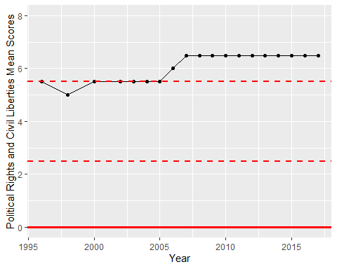

Freedom House Score Trend